SMART WASTE MANAGEMENT USING IOT

TEAM ID: PNT2022TMID26064

1.INTRODUCTION

* 1. Project Overview
  2. Purpose

2. Ideation Phase

2.1.Literature survey

2.2.Empathy Map Canvas

2.3.Brainstorming

3.Project design-I

3.1.Proposed Solution

3.2.Problem Solution fit

3.3. Solution architecture

4. Project Design-II

4.1.Customer Journey map

4.2. REQUIREMENT ANALYSIS

Functional requirement Non-Functional requirements

4.3. Technology Architecture

5.PROJECT PLANNING & SCHEDULING

5.1.Sprint Planning & Estimation

5.2.Sprint Delivery Schedule

6.Reports from JIRA

6.1.CODING & SOLUTIONING (Explain the features added in the project along with code)

6.2.Feature 1

6.3.Feature 2

6.4.Database Schema (if Applicable)

7.TESTING

7.1.Test Cases

7.2.User Acceptance Testing

8. RESULTS

8.1.Performance Metrics

9.ADVANTAGES & DISADVANTAGES

10.CONCLUSION

11.FUTURE SCOPE

12. APPENDIX Source Code

GitHub & Project Demo Link

* 1. PROJECT OVERVIEW

1. INTRODUCTION

Waste bins are part of our lives for decades and mostly its conditions are overflowing due to improper waste dumping, collection and management, which leads in foul smell and unhygienic condition, thus inherently results in environment pollution. Therefore, in this paper, design of a Waste Bin with real time monitoring is presented and a smart waste management system is proposed using the recent technical advancements of automation and Internet of Things (IoT). The capacitance sensor in the bin continuously monitors the level of the bin in real time and communicates to the central cloud where the bins are connected. Ultrasonic sensor is used to open and close the lid of the bin whenever the persons are nearby the bin. Such smart bins are connected to the cloud, where the bin status are communicated, recorded and monitored by the local bodies through and android app or a centralized server. Thus the designed smart bin and proposed waste management system have better level of smartness compared to existing ones in metropolitan cities in a centralized manner.

* 1. PURPOSE

A waste management system is the strategy an organization uses to dispose, reduce, reuse, and prevent waste. Possible waste disposal methods are recycling, composting, incineration, landfills, bio remediation, waste to energy, and waste minimization.

**2.IDEATION PHASE**

**2.1.LITERATURE SURVEY**

# ABSTRACT:

The paper is based on the concept of Automation used in waste management system under the domain of Cleanliness and Hygiene. Dumping garbage onto the streets and in public areas is a common synopsis found in all developing countries and this mainly end up affecting the environment and creating several unhygienic conditions. In order to deal with these problems Smart net bin is an ideology put forward which a combination of hardware and software technologies is i.e. connecting Wi-Fi system to the normal dustbin in order to provide free internet facilities to the user for a particular period of time. The technology awards the user for keeping the surrounding clean and thus work hand in hand for the proper waste management in a locality. Smart net bin uses multiple technologies firstly the technology for measuring the amount of trash dumped secondly the movement of the waste and lastly sending necessary signals and connecting the user to the Wi-Fi system. The proposed system will function on client server model, a cause that will assure clean environment, good health, and pollution free society.

**INTRODUCTION:**

The amount of waste produced everyday by the industries and the households is increasing at an appalling rate, and the major reason for this is soaring use of packaged items, textiles, paper, food, plastics, metals, glass etc, thus management of this refuse becomes a crucial part in our everyday life. In most of the developed countries there are many efficient techniques which are used for the proper management of this waste, but in some countries especially the developing ones the careless attitude of people towards maintaining clean surroundings, along with this many issues such as no stringent laws for using the biodegradable materials, no proper environ policies, no laws for sustainable development are the seed for the fatal results of waste management. Due to the increasing waste, the public bins which are used for collecting this waste are overflowing; the locality is jumbled of trash, causing not only malodorous streets but also a negative impact on the health and environment. Waste is a crucial issue, which needs to be addressed smartly. We segregate the waste at our homes for ease at processing and recycling.We observed trash vans come irregular to homes creating a despoliation of households. Due to this many civilians empty their overloaded dustbins in open spaces. This in turn increases environmental pollution the waste is a great hassle for our health and the environment it has many effects which are dreadful. Trash is breeding ground for bacteria, insects, flies these flies are the same that roam around the eatable and drop them off springs. Thus they increase the risk with food poisoning, typhoid, gastroenteritis, salmonella, the insects cause malaria dengue etc, beside these flies and insects other animals that prosper from the trash are the rats and the stray dogs spreading diseases, the garbage also causes various respiratory diseases the toxic contaminates such as co2 methane, nitrous oxide beside health issues adversely affect the environment causing air pollution water pollution. Disposal of hazardous waste like the electronic items, plastics in water affect the aquatic life and indirectly the human beings. Overflowing garbage is also a public hassle and eyesore. Everyone wants to visit fresh clean cities. A malodorous city with trash all around the place does not attract tourist thus loosing the money revenue and the opportunities. As prosperity grows, 62 million tons of garbage is generated everyday by the 377 million people living in urban India, now the world’s third largest garbage generator. However, it’s not the amount of waste generated that’s as much of an issue as the fact that more than 45 million tons, or 3million trucks worth, of garbage is untreated and disposed of by municipal authorities every day in an unhygienic manner. The internet nowadays has the world under its spell. Not a single person lives without internet, phone, tab or laptop. It is believed without connectivity u cannot move ahead in today’s world but sometimes due to heavy plans or connectivity issues we can’t access to the internet, and thus attracting people towards free Wi-Fi. Providing free Wi-Fi facility for dumping waste into the dustbin would solve the issue of waste and the internet facility plus availability of free service would help people go crazy and would act as reward for maintain cleanliness in the locality.

# LITERATURE REVIEW:

One issue that most cities and municipalities are dealing with is the degradation of environmental cleanliness with reference to waste management. This is a result of improper garbage collection management. The spread of trash in the neighborhood is a result of this poor management, which in turn generates unwholesome conditions in the neighborhood. Additionally, it encourages various significant illnesses among those nearby and a decline in the beauty of the region. To avoid improper garbage management and to enhance cleanliness the smart waste management system is created with the society in mind. Any city can be referred to be a "smart city" because of its orderly and tidy surroundings.

Currently, there are many issues facing modern cities, including those related to smart grids, smart environments, and smart living. Today, cities and metropolitan areas' top priority is proper garbage management. Traditional waste management techniques are too simplistic to create an effective and reliable waste management. Any smart city should place the highest focus on smart waste management because it has a direct impact on people's way of life, health, and environment. The Smart Garbage Monitoring System, the Wise Waste Segregation System, and the Smart Waste Collection System are only a few of the several potential ways for smart bin systems that are discussed in this article. We also suggest a framework for an intelligent garbage management system in addition to this survey.

# PROS:

* Advancement of smart city system.
* Effective management of the city waste helps people life style to improve
* Making the garbage system an IoT application opens path to a lot of different opportunities.
* Hands on Device system for garbage system helps to have a more detailed update on the disposal system.

# APPLICATIONS:

* Can be implemented in highly trafficking system.
* Apartment based lifestyle has a huge requirement for this kind of system.
* Helps city people to have an update on garbage system.

**CONCLUSION:**

Solid waste management is faced with a number of issues which include lack of throughput, inadequate solid waste data, efficiency problem, delays in collection and resistance to new technologies. Presently, waste management is a major problem for authorities who are responsible for such task because it’s a costly service and it hugely impacts the environment as a whole. This study introduced a smart waste monitoring system that uses several sensors and communication technologies to achieve the set task. The proposed system was achieved through the development of theoretical Models, layout and decision-making algorithms in the course of the project. There is an enormous amount of room for the development of this project in order for it to meet commercial standards. One of my many recommendations would be that of the addition of other sensors e.g. accelerometer. The accelerometer will make the system save more energy by turning on the system to measure the bin level only when the lid is opened to dispose waste. The system would then update its current state on Thing Speak and turn off, preventing unnecessary measurement when the bin’s level has not been altered due to dormancy. Another recommendation is the use of solar panel for power generation making its power supply autonomous.

**2.2. EMPATHY MAP CANVAS**

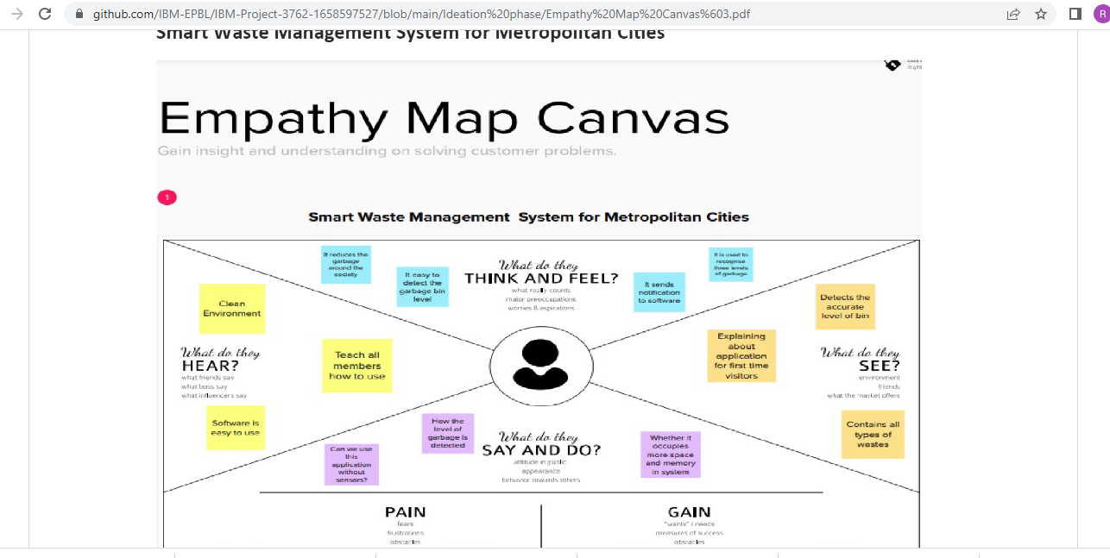

**2.3 BRAIN STORM**

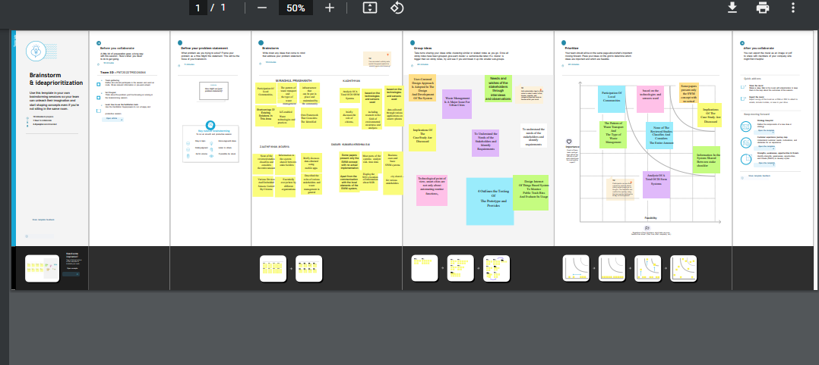

**3.PROJECT DESIGN PHASE –I**

**3.1.PROPOSED SOLUTION**

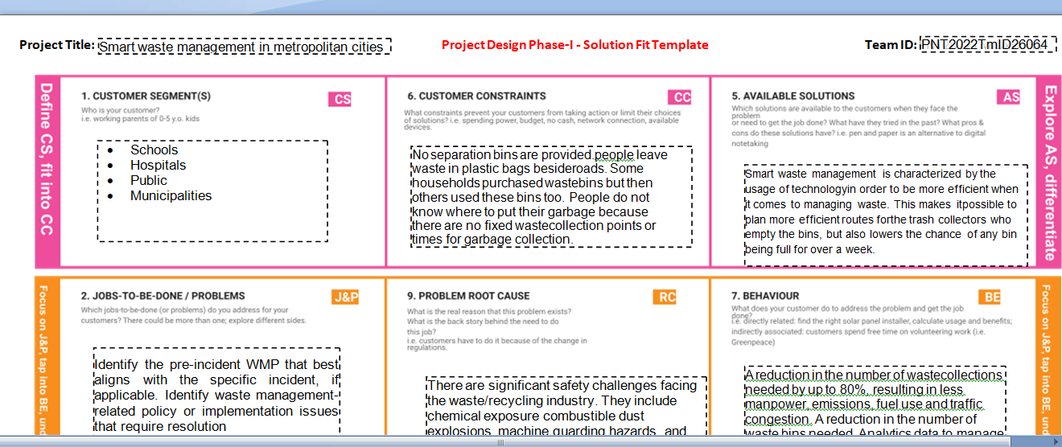

**3.2.PROPOSED SOLUTION FIT**

**PROPOSED SOLUTION TEMPLATE :**

|  |  |  |
| --- | --- | --- |
| **S.NO.** | **PARAMETER** | **DESCRIPTION** |
| 1 | Problem Statement ( Problem to be solved) | * This project deals with the problem of waste management in smart cities, where the garbage collection system is not optimized * Rotting garbage is also known to produce harmful gases mix with the air and cause breathing problem in people. |
| 2 | Idea / Solution description | * To solve this problem of waste management for disposal using a smart refuse- bin built with technologies   like Sensors, Arduino Yun. |

|  |  |  |
| --- | --- | --- |
|  |  | * The Proposed system consists of main subsystems namely Smart Trash System(STS) and Smart Monitoring and Controlling Hut(SMCH). * AI Recycling Robots. |
| 3 | Novelty / Uniqueness | * Identify potential waste streams. * Create a waste   management-focused community outreach plane. |
| 4 | Social Impact / Customer Satisfaction | * Neighborhood of landfills to communities, breeding of pests and loss in property values. * From the public perception as worst impacts of present solid waste disposal practices are seen direct social impacts such as neighbourhood of   landfills to communities, breeding of pests and loss in property values |
| 5 | Business Model (Revenue Model) | * It generates revenue through the provision of various waste management and disposal services. * Recycling solutions to residential, commercial,   industrial, and municipal clients |
| 6 | Scalability of the Solution | * Installing more bins fir collecting recyclables like paper, glass, plastic. * Following this approach, this paper presented an efficient IoT- based and real-time waste management model for improving the living environment in cities, focused on a citizen perspective   ❖ Recycling not only save energy but also prevent the material from going to landfills & Incineration and  provides raw materials for new products. |

**3.3. SOLUTION ARCHITECTURE**

**Solution Architecture:**

Solution architecture is a complex process – with many sub-processes – that bridges the gap between business problems and technology solutions. Its goals are to:

* Find the best tech solution to solve existing business problems.
* Describe the structure, characteristics, behaviour, and other aspects of the software to project stakeholders.
* Define features, development phases, and solution requirements.
* Provide specifications according to which the solution is defined, managed, and delivered.

**Example - Solution Architecture Diagram:**

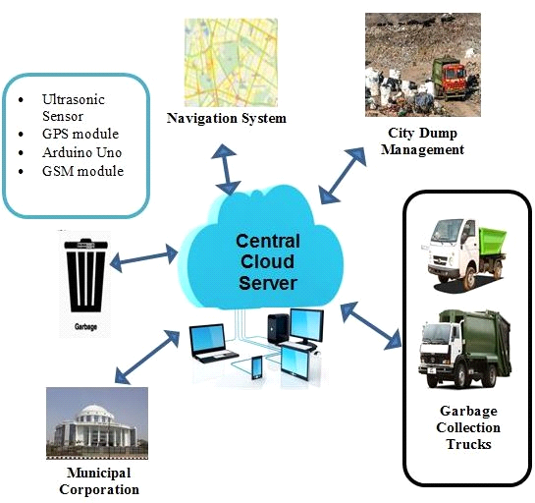

4. PLANNING DESIGN PHASE-II

4.1.CUSTOMER JOURNEY MAP

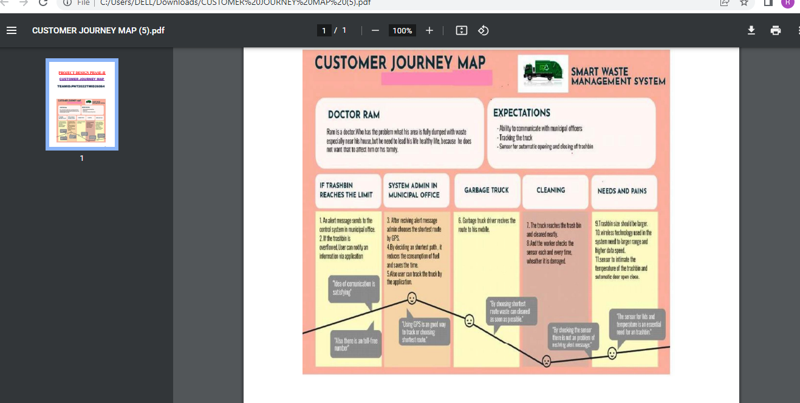

**4.2.** FUNCTIONAL AND NON_FUNCTIONAL REQUIREMENTS

Functional Requirements :

Following are the functional requirements of the proposed solution.

|  |  |  |
| --- | --- | --- |
| **FR NO** | **Functional Requirement (Epic)** | **Sub Requirement (Story / Sub- Task)** |
| FR-1 | Detailed bin inventory | * All monitored bins and stands can be seen on the map, and you can visit them at any time via the Street View feature from Google. * Bins or stands are visible on the map as green, orange or red circles. * You can see bin details in the Dashboard – capacity, waste type, last measurement, GPS location and collection schedule or pick   recognition. |

|  |  |  |
| --- | --- | --- |
| FR-2 | Real time bin monitoring | * The Dashboard displays real-time data on fill-levels of bins monitored by smart sensors. * In addition to the % of fill-level, based on the historical data, the tool predicts when the bin will become full, one of the functionalities that are not included even in the best waste management software. * Sensors recognize picks as well; so you can check when the bin was last collected. * With real-time data and predictions, you can eliminate the overflowing bins and stop collecting half-   empty ones. |
| FR-3 | Expensive bins | * We help you identify bins that drive up your collection costs. The tool calculates a rating for each bin in terms of collection costs. * The tool considers the average distance depo-bin discharge in the area. The tool assigns bin a rating (1-10) and calculates distance from   depo-bin discharge |
| FR-4 | Adjust bin distribution | * Ensure the most optimal distribution of   bins. Identify areas |

|  |  |  |
| --- | --- | --- |
|  |  | with either dense or sparse bin distribution.   * Make sure all trash types are represented within a stand. * Based on the historical data, you can adjust bin capacity or location   where necessary |
| FR-5 | Eliminate unefficient picks | * Eliminate the collection of half- empty bins. The sensors recognize picks. * By using real-time data on fill-levels and pick recognition, we can show you how full the bins you collect are. * The report shows how full the bin was when picked. You immediately see   any inefficient picks below 80% full. |
| FR-6 | Plan waste collection routes | * The tool semi- automates waste collection route planning. * Based on current bin fill- levels and predictions of reaching full capacity, you are ready to respond and schedule waste collection. * You can compare planned vs. executed routes to identify any   Inconsistencies |

Non-functional Requirements:

Following are the non-functional requirements of the proposed solution.

|  |  |  |
| --- | --- | --- |
| **FR NO.** | **Non-Functional Requirement** | **Description** |
| NFR-1 | **Usability** | IoT device verifies that usability is a special and important perspective to analyze user requirements, which can further improve the design quality.  In the design process with user experience as the core, the analysis of users’ product usability can indeed help designers better understand users’ potential needs in waste management, behavior  and experience. |
| NFR-2 | **Security** | Use a reusable bottles Use reusable grocery bags  Purchase wisely and recycle  Avoid single use food and drink container. |
| NFR-3 | **Reliability** | Smart waste management is also about creating better working conditions for waste collectors and drivers.  Instead of driving the same collection routes and servicing empty bins, waste collectors will spend their time more efficiently, taking  care of bins |

|  |  |  |
| --- | --- | --- |
|  |  | that need servicing |
| NFR-4 | **Performance** | Using a variety of IoT networks (NB- IoT,GPRS), the sensors send the data to Sensono's Smart Waste Management Software System, a powerful cloud-based platform, for data driven daily operations, available also as a waste management app.  Customers are hence provided data-driven decision making, and optimization of waste collection routes, frequencies, and vehicle loads resulting in route reduction by at least  30%. |
| NFR-5 | **Availability** | By developing & deploying resilient hardware and beautiful software we empower cities, businesses, and  countries to manage waste smarter. |
| NFR-6 | **Scalability** | Using smart waste bins reduce the number of bins inside town , cities coz we able to monitor the garbage 24/7 more cost effect and  scalability when we moves to smarter. |

4.3. TECHNOLOGY ARCHITECTURE

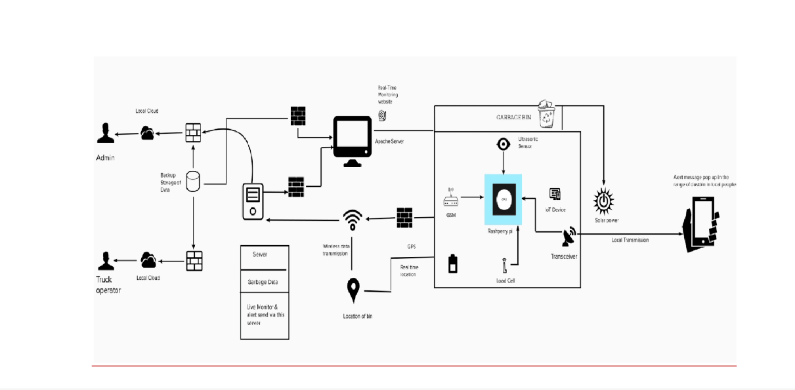

**5.** PROJECT PLANNING AND SCHEDULING

SPRINT PLANNING & ESTIMATION

|  |  |  |
| --- | --- | --- |
| PHASE | TITLE | DESCRIPTION |
| Ideation Phase | Literature Survey & Information Gathering | Literature survey on the selected project & gathering information by referring the, technical papers, research  publications etc. |
| Prepare Empathy Map | Prepare Empathy Map Canvas to capture the user Pains & Gains, Prepare list of problem statements |
|  | Ideation | List the by organizing the brainstorming session and prioritize the top 3 ideas based on the feasibility & importance. |

|  |  |  |
| --- | --- | --- |
| Phase-1 | Proposed Solution | Prepare the proposed solution document, which includes the novelty, feasibility of idea, business model, social impact, scalability  of solution, etc. |
| Problem Solution Fit | Prepare problem - solution fit document. |
| Solution Architecture | Prepare solution architecture document. |
| Phase-2 | Customer Journey | Prepare the customer journey maps to understand the user interactions & experiences with the  application (entry to exit) |
| FunctionalRequirement | Prepare the functional and Nonfunctional  requirement document. |
| Data Flow Diagrams | Draw the data flow  diagrams and submit for review. |
| Technology Architecture | Prepare the technology  architecture diagram. |
| Project planning phase | Prepare Milestone & Activity List | Prepare the milestones & activity list of the project. |

|  |  |  |
| --- | --- | --- |
| Project development phase | Project Development - Delivery of Sprint-1, 2, 3  & 4 | Develop & submit the developed code by testing it. |

**SPRINT DELIVERY SCHEDULE**

|  |  |  |  |  |  |  |
| --- | --- | --- | --- | --- | --- | --- |
| Sprint | Function al Require ment (Epic) | User Story Number | User Story  / Task | Stor y Point s | Priority | Team Members |
| Sprint-1 | Login | USN-1 | Administrator, I need to give user id and passcode for ever workers over there in  municipality | 10 | High | Eswar |
| Sprint-1 | Login | USN-2 | As a Co- Admin, I’ll control the waste level by monitoring them vai real time web portal. Once the filling happens, I’ll notify trash  truck with | 10 | High | Eswari |

|  |  |  |  |  |  |  |
| --- | --- | --- | --- | --- | --- | --- |
|  |  |  | location of  the bin. |  |  |  |
| Sprint-2 | Dashboar  d | USN-3 | As a Truck  Driver, I’ll follow Co- Admin’s Instruction to reach the filling bin in short roots and save time | 20 | Low | Jevitha |
| Sprint-2 | Dashboar  d | USN-3 | As a Truck  Driver, I’ll follow Co- Admin’s Instruction to reach the filling bin in short roots and save time | 20 | Low | Jevitha |
| Sprint-3 | Dashboar  d | USN-4 | As a Local  Garbage Collector, I’II gather all the waste from the garbage, load it onto a  garbage | 20 | Medium | Ashley  Ebetha |

|  |  |  |  |  |  |  |
| --- | --- | --- | --- | --- | --- | --- |
|  |  |  | truck, and  deliver it to Landfills |  |  |  |
| Sprint-4 | Dashboar d | USN-5 | As a Municipality officer, I'll make sure everything is proceeding as planned and  without any problem | 20 | High | Ashika |

## PROJECT TRACKER, VELOCITY & BURNDOWN CHART

|  |  |  |  |  |  |  |
| --- | --- | --- | --- | --- | --- | --- |
| **Sprint** | **Total Story Points** | **Duration** | **Sprint Start Date** | **Sprint End Date** | **Story Points Complet ed (as on Planned End**  **Date)** | **Sprint Release Date (Actual)** |
| Sprint-1 | 20 | 6 Days | 24 Oct  2022 | 29 Oct  2022 | 20 | 29 Oct 2022 |
| Sprint-2 | 20 | 6 Days | 31Oct  2022 | 05 Nov  2022 | 20 | 05 Nov 2022 |
| Sprint-3 | 20 | 6 Days | 07Nov  2022 | 12 Nov  2022 | 20 | 12 Nov 2022 |
| Sprint-4 | 20 | 6 Days | 14 Nov  2022 | 19 Nov  2022 | 20 | 19 Nov 2022 |

**Reports from JIRA:**

## Burnout Chart:

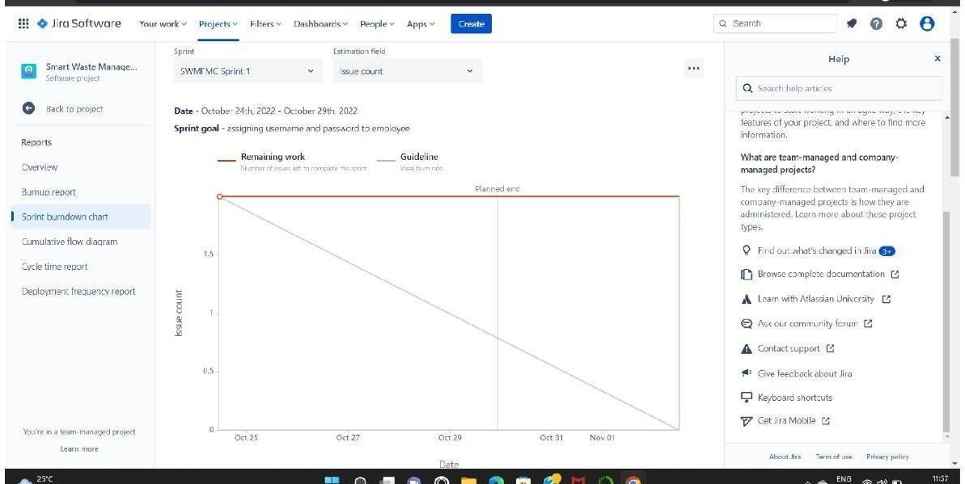

**Road Map:**

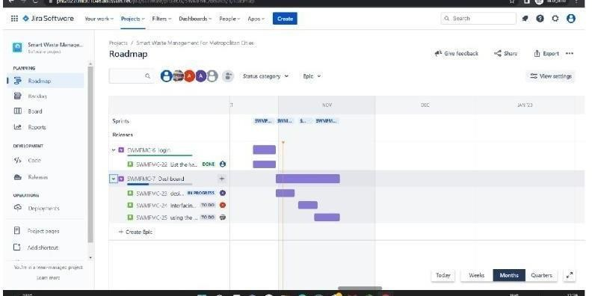

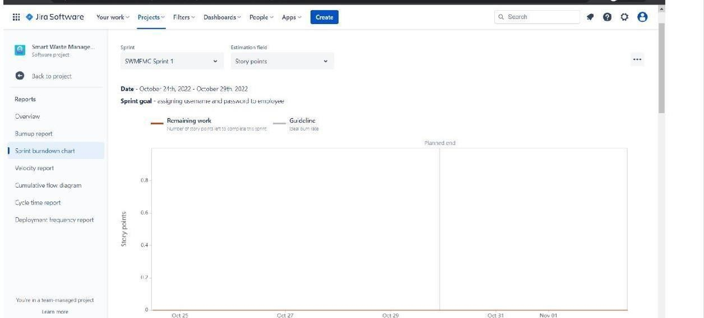

**6.1. Feature 1- LOCATION TRACKER:**

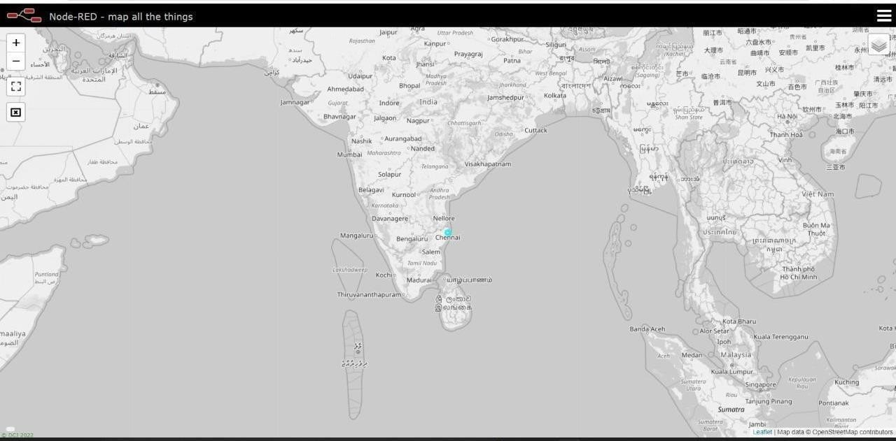

# 6.2 Feature 2- LIVE UPDATE ON COLLECTED DATA:

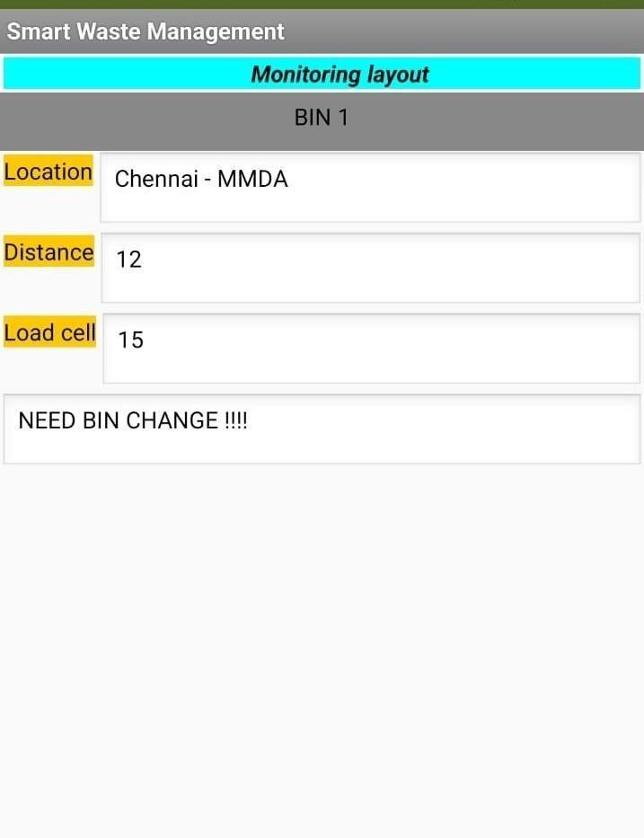

7.TESTING

# 7.1. TESTCASES:

|  |  |  |  |  |  |  |  |  |  |  |  |  |  |
| --- | --- | --- | --- | --- | --- | --- | --- | --- | --- | --- | --- | --- | --- |
| TE ST C A SE ID | FEAT URE TYPE | CO MP ONE NT | TEST SCENARI O | PR ER EQ UI ST E | STEP S TO EXEC UTE | TEST DAT A | EXECU TED RESUL T | ACTU AL RESU LT | STAT US | COM MEN TS | TC FOR AUT OMA TION( Y/N) | B U G ID | EX EC UT ED BY |
| L | FUN | HO | VERIFY |  | 1.EN | https:/ | L0gin | Worki | PASS | Succe |  |  |  |
| O | CTO | M | THE USER | T | / | page is | ng as |  | ssful |
| GI | NA L | E | IS ABLE | ER | 1 | visible | expect |  |  |
| N |  | PAG | TO SEE | URL | 69.51. |  | ed |  |  |
| P |  | E | THE | AND | 2 |  |  |  |  |
| A |  |  | LOGIN/SI | CLIC | 0 |  |  |  |  |
| G |  |  | G | K | 4.219. |  |  |  |  |
| E_ |  |  | N UP | GO | 3 |  |  |  |  |
| T |  |  | WEN | 2.VE | 0 |  |  |  |  |
| C |  |  | USER | R | 106 |  |  |  |  |
| _0 |  |  | CLICK ON | IFY |  |  |  |  |  |
| 01 |  |  | MY | LOGI |  |  |  |  |  |
|  |  |  | ACCOUN | N/SI |  |  |  |  |  |
|  |  |  | T | GN |  |  |  |  |  |
|  |  |  | BUTTON | UP |  |  |  |  |  |
| L |  | LOG | VERIFY |  | 1.EN | https:/ | Applica | Worki | PASS | Succ |  |  |  |
| O | UI | IN | THE USER | T | / | t | n |  | ess |
| GI |  | PAG | IS ABLE | ER | 1 | ion | g as |  | ful**l** |
| N |  | E_T | TO SEE | URL | 69.51. | should | expect |  |  |
| P |  | C | THE | AND | 2 | show | e |  |  |
| A |  | _002 | LOGIN/SI | CLIC | 0 | below | d |  |  |
| G |  | UI | G | K | 4.219. | UI |  |  |  |
| E_ |  | HO | N UP | GO | 3 | elemen |  |  |  |
| T |  | M | WEN | 2.VE | 0 | t |  |  |  |
| C |  | E | USER | R | 106 |  |  |  |  |
| _0 |  | PAG | CLICK ON | IFY |  |  |  |  |  |
| 02 |  | E | MY | LOGI |  |  |  |  |  |
|  |  |  | ACCOUN | N/SI |  |  |  |  |  |
|  |  |  | T | GN |  |  |  |  |  |
|  |  |  | BUTTON | UP |  |  |  |  |  |
|  |  |  |  | Eleme |  |  |  |  |  |
|  |  |  |  | nts |  |  |  |  |  |
|  |  |  |  | a.ID |  |  |  |  |  |
|  |  |  |  | text |  |  |  |  |  |
|  |  |  |  | b o |  |  |  |  |  |
|  |  |  |  | x |  |  |  |  |  |
|  |  |  |  | B |  |  |  |  |  |
|  |  |  |  | . |  |  |  |  |  |

|  |  |  |  |  |  |  |  |  |  |  |  |  |  |
| --- | --- | --- | --- | --- | --- | --- | --- | --- | --- | --- | --- | --- | --- |
|  |  |  |  |  | passw ord text box c..logi n butto n D.ne w user E.alre ady have an accou nt |  |  |  |  |  |  |  |  |
| L O GI N P A G  E_ T C  _0 03 | FUN CTI ONA L | LOG I  N PAG E | VERIFY THE USER IS ABLE TO SEE THE LOGIN/SI G  N UP WEN USER CLICK ON MY ACCOUN T BUTTON |  | 1.ent er url and click go 2.clic k  on my accou nt 3.Ent er valid ID  4.Ent er valid passw ord 5.clic k  on login | Id:11 11  passw o  r d:567 8 | User should navigat e your home page. | Worki n  g as expect e  d | PASS | Succ ess ful |  |  |  |
| L O GI N P A G  E_ T  C_ | FUN CTI ONA L | LOG I  N | VERIFY THE USER IS ABLE TO SEE THE LOGIN/SI G  N UP WEN USER |  | 1.ent er url and click go 2.clic k  on my accou nt | Id:11 11  pass wor d:56 78 | Confir mation messag e  sent | Worki ng as expect e  d | PASS | Succ essful |  |  |  |

|  |  |  |  |  |  |  |  |  |  |  |  |  |  |
| --- | --- | --- | --- | --- | --- | --- | --- | --- | --- | --- | --- | --- | --- |
| 00  4 |  |  | CLICK ON MY ACCOUN T BUTTON |  | 3.Ente r  valid ID  4.Ente r  valid passw ord 5.clic k  on login butvto n |  |  |  |  |  |  |  |  |
| L O GI N P A G  E_ T  C_ 00  5 | UI | LOG IN PAG E | VERIFY THE USER IS ABLE TO SEE THE LOGIN/SI G  N UP WEN USER CLICK ON MY ACCOUN T BUTTON |  | 1.ente r  url and click go 2.clic k  on my accou nt 3.Ente r  valid ID  4.Ente r  valid passw ord 5.clic k  on login button | Id:1 111  pass wor d:56 78 | Confir m ation messag e  sent | Worki n  g as expect e  d | PASS | Succe ss  ful |  |  |  |
| L O GI N P A G  E_ T  C_ 00 | FUN CTIO NA  L | LOG IN PAG E FOR AD MIN | VERIFY THE USER IS ABLE TO SEE THE LOGIN/SI G  N UP WEN USER CLICK ON |  | 1.ente r  url and click go 2.clic k  on my accou nt | Id:1 111  pass wor d:56 78 | Custom er databas e is visible | Worki n  g as expect e  d | PASS | Succe ss  ful |  |  |  |

|  |  |  |  |  |  |  |  |  |  |  |  |  |  |
| --- | --- | --- | --- | --- | --- | --- | --- | --- | --- | --- | --- | --- | --- |
| 6 |  |  | MY ACCOUN T BUTTON |  | 3.Ente r  valid ID  4.Ente r  valid passw ord 5.clic k  on login button |  |  |  |  |  |  |  |  |

**7.2.USER ACCEPTANCE TESTING:**

1. PURPOSE OF DOCUMENT

The purpose of this document is to briefly explain the test coverage and open issues of the [Product Name] project at the time of the release to User Acceptance Testing (UAT).

1. DEFECT ANALYSIS

This report shows the number of resolved or closed bugs at each severity level, and how they were Resolved.

|  |  |  |  |  |  |
| --- | --- | --- | --- | --- | --- |
| **Resolution** | **Severity 1** | **Severity 2** | **Severity 3** | **Severity 4** | **Subtotal** |
| By Design | 10 | 4 | 2 | 3 | 20 |
| Duplicate | 1 | 0 | 3 | 0 | 4 |
| External | 2 | 3 | 0 | 1 | 6 |
| Fixed | 11 | 2 | 4 | 20 | 37 |
| Not Reproduced | 0 | 0 | 1 | 0 | 1 |
| Skipped | 0 | 0 | 1 | 1 | 2 |
| Won't Fix | 0 | 5 | 2 | 1 | 8 |

|  |  |  |  |  |  |
| --- | --- | --- | --- | --- | --- |
| Totals | 24 | 14 | 13 | 26 | 7 |

* 1. **TEST CASE ANALYSIS:**

This report shows the number of test cases that have passed, failed, and untested

|  |  |  |  |  |
| --- | --- | --- | --- | --- |
| **Section** | **Total Cases** | **Not Tested** | **Fail** | **Pass** |
| Print Engine | 7 | 0 | 0 | 7 |
| Client Application | 51 | 0 | 0 | 51 |
| Security | 2 | 0 | 0 | 2 |
| Outsource shipping | 3 | 0 | 0 | 3 |
| Exception reporting | 9 | 0 | 0 | 9 |
| Final report output | 4 | 0 | 0 | 4 |
| Version control | 2 | 0 | 0 | 2 |

8.RESULTS

**8.1. PERFORMANCE METRICEES:**

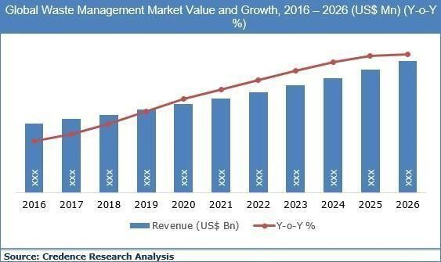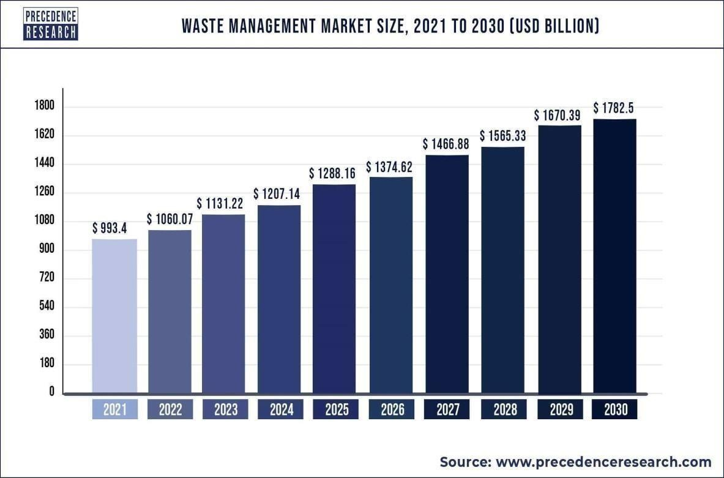

9. ADVANTAGES & DISADVANTAGES

**ADVANTAGES**

* + - Reduction in Collection Cost
      * No Missed Pickups
      * Reduced Overflows
      * Waste Generation Analysis
      * CO2 Emission Reduction

**DISADVANTAGES**

* System requires a greater number of waste bins for separate waste collection as per population in the city.
  + This results into high initial cost due to expensive smart dustbins compare to other methods. Sensor nodes used in the dustbins have limited memory size.

# 10. CONCLUSION

A Smart Waste Management system that is more effective than the one in use now

is achievable by using sensors to monitor the filling of bins. Our conception of a "smart waste management system" focuses on monitoring waste management, offering intelligent technology for waste systems, eliminating human intervention, minimizing human time and effort, and producing a healthy and trash-free environment. The suggested approach can be implemented in smart cities where residents have busy schedules that provide little time for garbage management. If desired, the bins might be put into place in a metropolis where a sizable container would be able to hold enough solid trash for a single unit.

**11. FUTURE SCOPE**

There are several future works and improvements for the proposed system, including the following:

1. Change the system of user authentication and atomic lock of bins, which would aid in protecting the bin from damage or theft.
2. The concept of green points would encourage the involvement of residents or end users, making the idea successful and aiding in the achievement of collaborative waste management efforts, thus fulfilling the idea of Swachh Bharath.
3. Having case study or data analytics on the type and times waste is collected on different days or seasons, making bin filling predictable and removing the reliance on electronic components, and fixing the coordinates.
4. Improving the Server's and Android's graphical interfaces

.

12. Appendix

SOURCE CODE

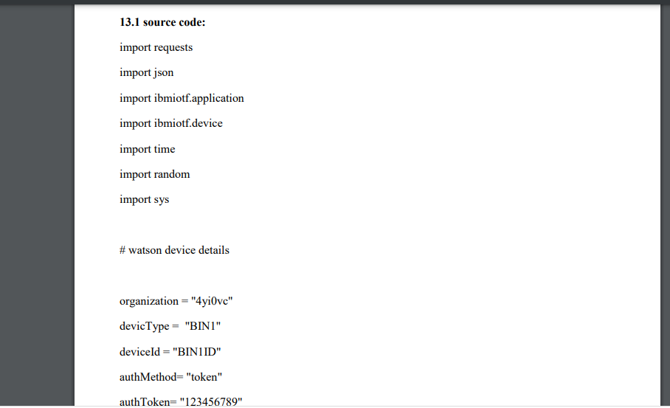

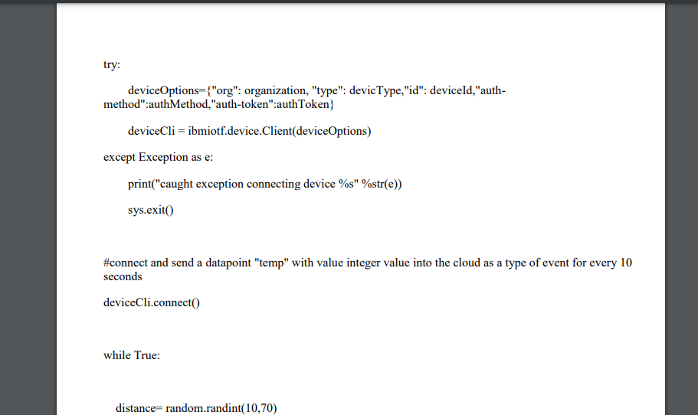

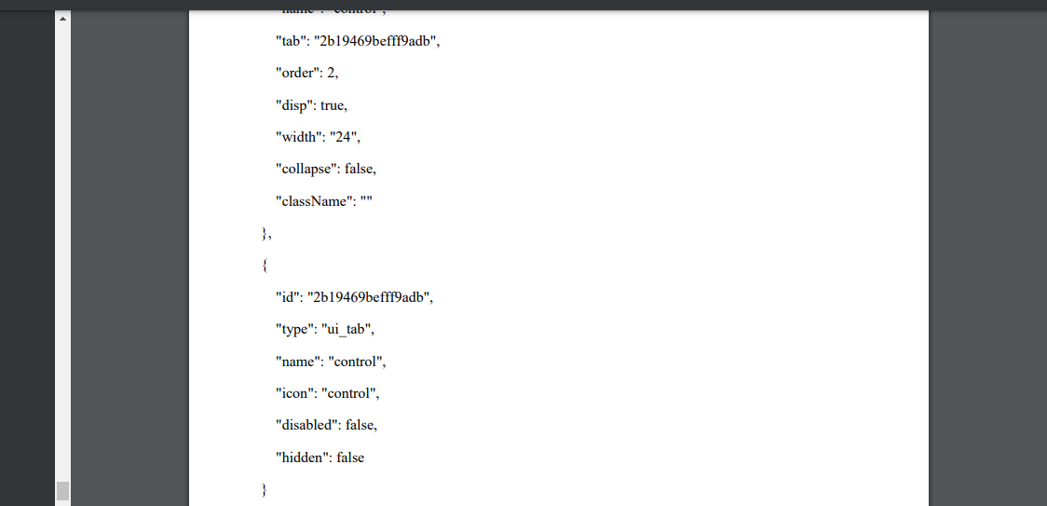

## Git hub link: https://github.com/IBM-EPBL/IBM-Project-3762-1658597527

**Project demo link: https://drive.google.com/file/d/1NJqaBjwTIMxCZTqVC-DIuTTZKx_hwRkN/view?usp=drivesdk**